Supplementary Materials for “Numerical analysis and model development for laminar flame speed of stratified methane/air mixtures”
  - Submitted to Combustion and Flame
Xian Shi, Jyh-Yuan Chen
Department of Mechanical Engineering, University of California, Berkeley, Berkeley, CA 94720, USA

Part 1 – Reduced chemical kinetic model validation

This part of the supplementary materials aims to provide validation for the reduced chemical kinetic model used in the paper. The reduced model has 16 species and is developed from a short version of GRI 3.0 model without NO_{X} chemistry, using Quasi Steady-State Approximation (QSSA).

Laminar flame speed results from experiments, numerical simulations with the detailed GRI 3.0 model, and those with the reduced model, are first compared as shown in Figure S1. Fuel consumption speed is used as the reference laminar flame speed in the simulations, while experimental measurements come from various experimental setups, including counter-flow, spherical expanding and flat flames. Please refer to specific papers for more details about the experimental measurements of laminar flame speeds. Figure S1 shows that the numerical results with both detailed and reduced models match well with the experimental observations.

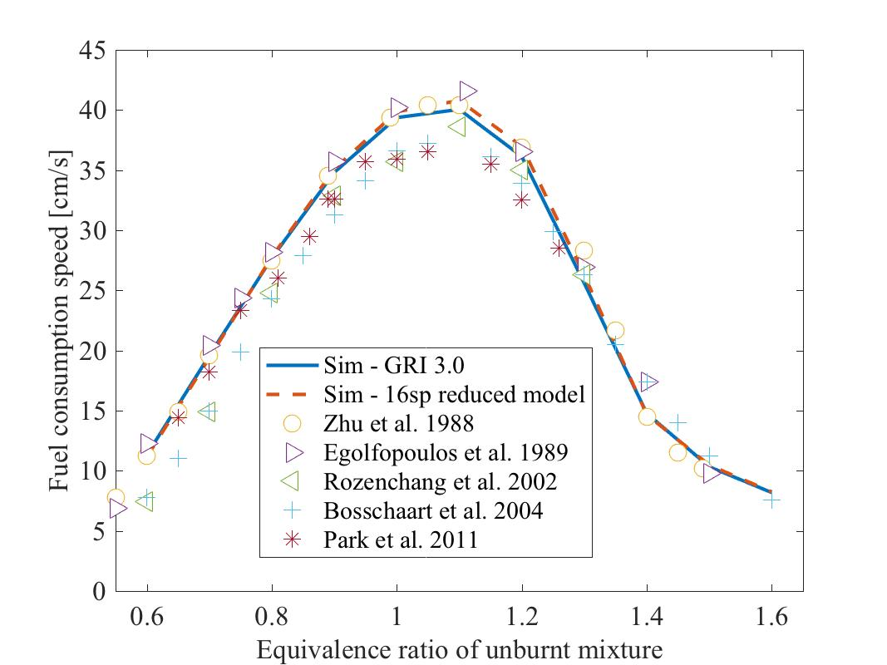

Figure S1: Laminar flame speeds of homogeneous methane/air flames at 300K, 1atm

In addition, mole fraction profiles of H2, H and OH at different equivalence ratios from numerical simulations with GRI 3.0 model are also compared to those with the reduced model, as these intermediate species and radicals play an important role in stratified flames. The comparison is shown in Figure S2. The results from the reduced model match very well with those from the detailed model over a wide range of equivalence ratios.
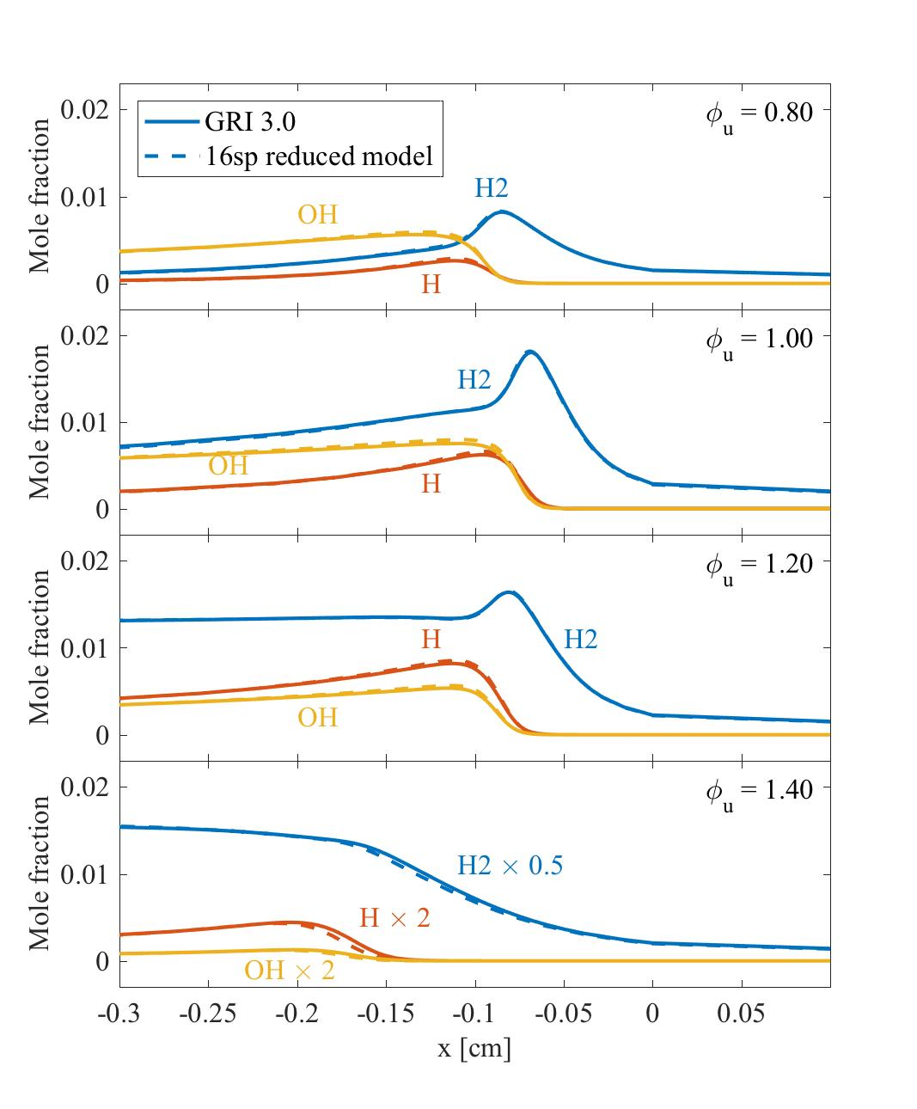
Figure S2: Comparison between numerical results of mole fraction profiles of H2, H and OH at different equivalence ratios, with GRI 3.0 model and the 16-species reduced model

Part 2 – LSL model fitting parameters

This part provides polynomial fitting parameters for the transfer function $f(ϕ)$. A 9-order polynomial fitting is used fit $f(ϕ)$ over the range of $ϕ$ from 0.6 to 1.6. The fitting parameters are as below

$$ϕ^{9}$$ | $$ϕ^{8}$$ | $$ϕ^{7}$$ | $$ϕ^{6}$$ | $$ϕ^{5}$$
-4.40E+03 | 4.26E+04 | -1.81E+05 | 4.41E+05 | -6.80E+05
$$ϕ^{4}$$ | $$ϕ^{3}$$ | $$ϕ^{2}$$ | $$ϕ^{1}$$ | $$ϕ^{0}$$
6.89E+05 | -4.57E+05 | 1.92E+05 | -4.65E+04 | 4.92E+03

Part 3 – LSL model assessment

This part provides LSL model assessment of three stratified flame cases which are not shown in the main text. Figure S3-S5 present the assessment of 1) rich-to-lean stratified flame, d_{s} = O(0.05 cm), 2) rich-to-lean stratified flame, d_{s} = O(1 cm), 3) lean-to-rich stratified flame, d_{s} = O(0.1 cm). The results are plotted against local equivalence ratio. The model results match relatively well with simulation results for all three cases.
Furthermore, different time steps for LSL model are also tested. For the case presented in Fig. S4, three different time steps for LSL, i.e., ts, 10ts, 100ts, where ts is the simulation time step, are used and the corresponding results are shown in Figure S6. The three cases produce almost identical results, as the differences among them are under 1%.

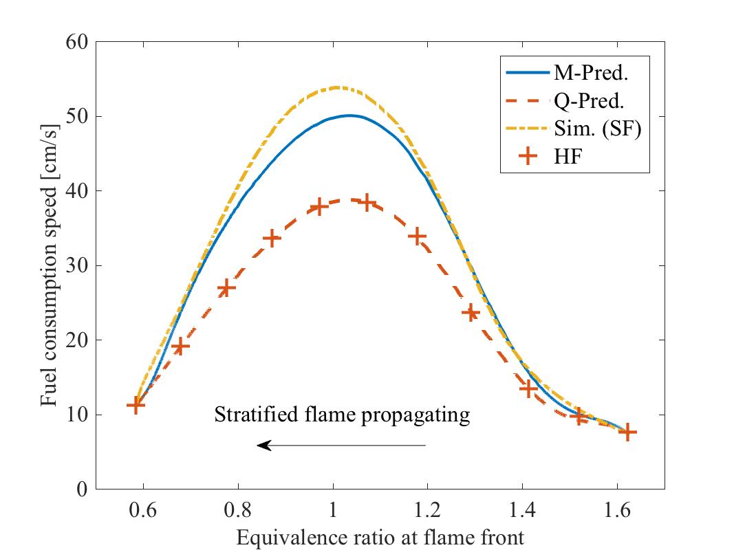

Figure S3: Local stratification level model assessment of the rich to lean stratified flame, d_{s} = O(0.05 cm). The results are plotted against local equivalence ratio.

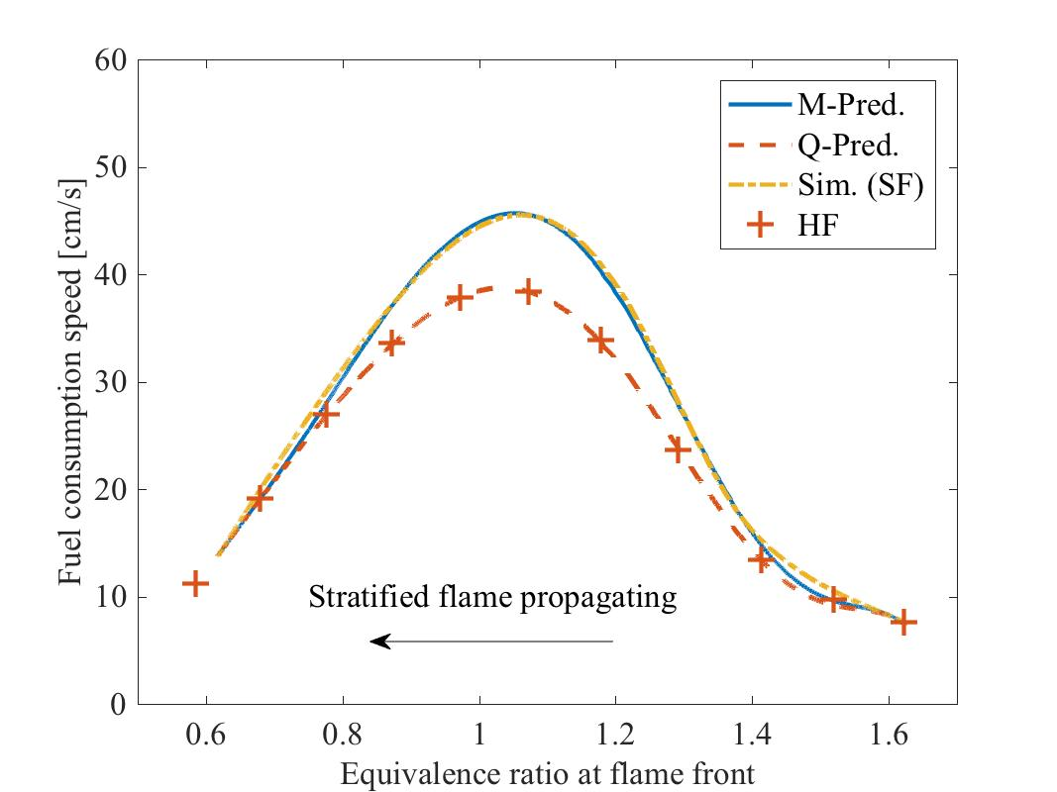

Figure S4: Local stratification level model assessment of the rich to lean stratified flame, d_{s} = O(1 cm). The results are plotted against local equivalence ratio.
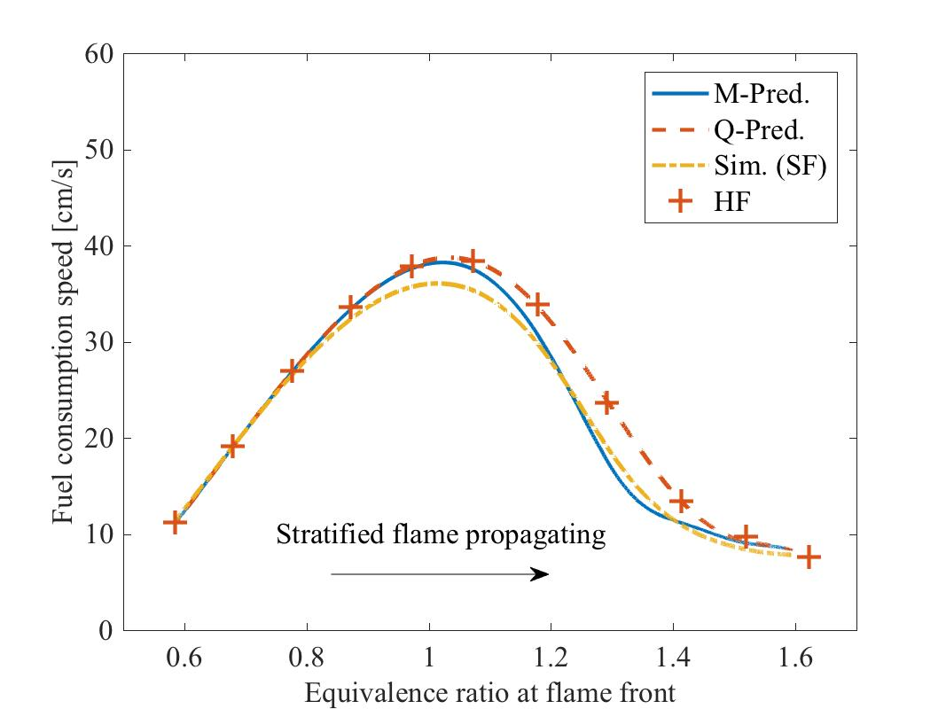

Figure S5: Local stratification level model assessment of the lean to rich stratified flame, d_{s} = O(0.1 cm). The results are plotted against local equivalence ratio.
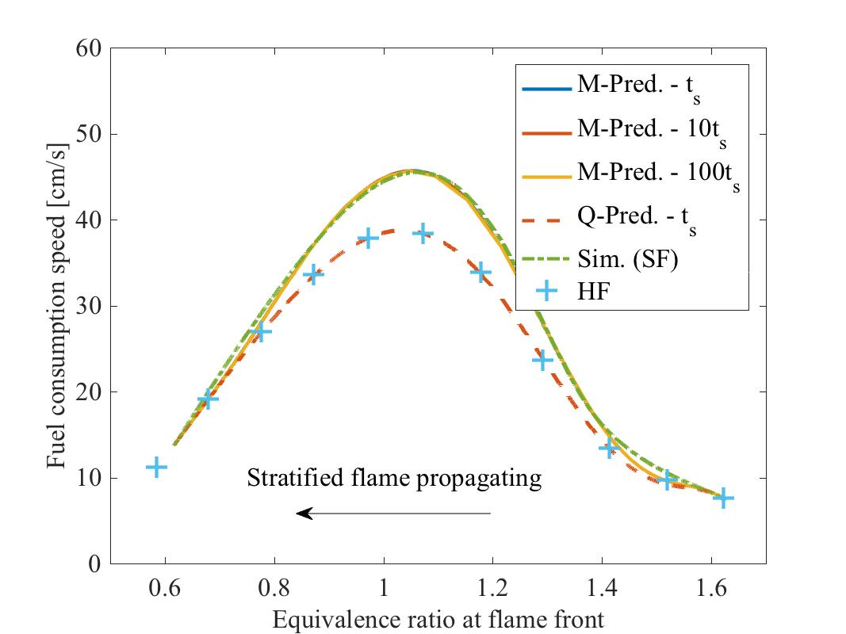

Figure S6: Time step test for local stratification level model of the rich to lean stratified flame, d_{s} = O(1 cm). The results are plotted against local equivalence ratio.
Part 4 – Transient profiles of Local Stratification Level at flame front, δ_{f}

This part provides the transient profiles of LSL at flame front, δ_{f}, for all the six validation cases provided in the main text (Fig. 21, 22). The results are shown in Figure S7.

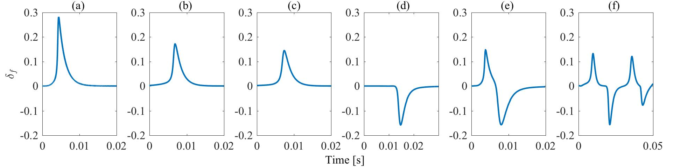

Figure S7: Transient profiles of LSL at flame front: (a) rich-to-lean, d_{s} = O(0.05 cm), (b) rich to lean, d_{s} = O(0.1 cm), (c) rich to lean, d_{s} = O(1 cm), (d) lean to rich, d_{s} = O(0.1 cm), (e) rich-lean-rich, (f) arbitrary equivalence ratio profile.

